DEPARTMENT OF ANATOMY

Sl. No | Name of Faculty | Designation | Registration No | Date of Birth | Date of Joining (SBHMCH) | Qualification | Experience | Photo
1 | Dr. P. Victor Dass | Professor | A 565 | 22.04.1968 | 01.04.2021 | DHMS, MD | 25.9 Years | 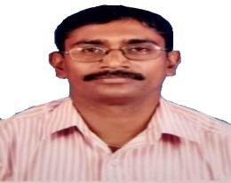
2 | Dr. V. Kaviyan | Associate Professor | A 4190 | 20.08.1987 | 22.01.2025 | BHMS, MD | 4.10 Years | 
3 | Dr.T.SATHIS KUMAR | Associate Professor | A 1119 | 01/07/1974 | 29.01.2026 | BHMS,Msc(Ana) | 18.2 Years | 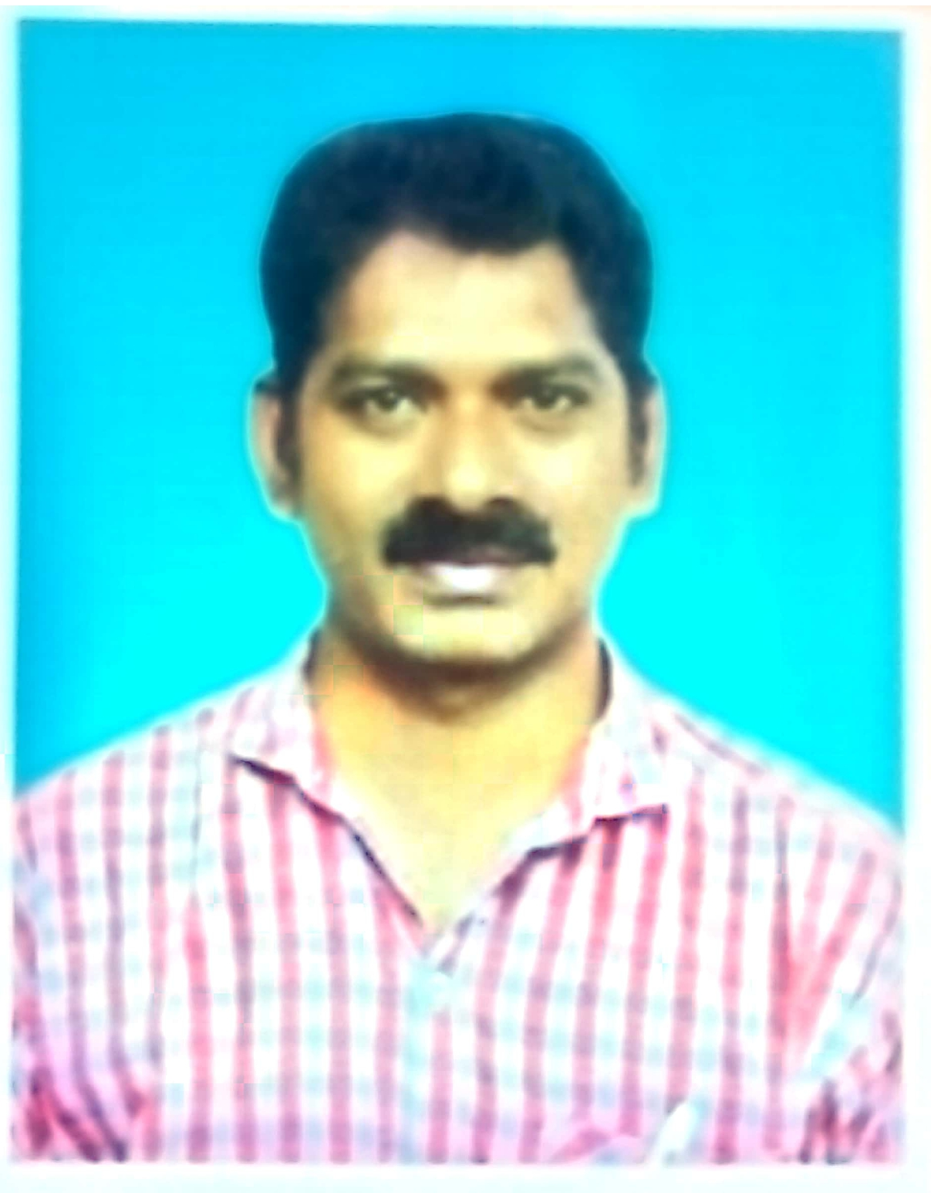
3 | Dr. S.K. Parithooran | Assistant Professor | 119291 | 09.12.1992 | 21.07.2025 | MBBS, MS (Ortho) | 6 Months | 